Hello Everyone:
My apologizes for not getting this to you, but this has been a very strange time. It is a time where we should be celebrating summertime, having cookouts, being with family and friends, as well as celebrating with the highland games, but it seems that 2020 has decided to give us one of the most challenging years we have seen since WWII. All across the United States and the United Kingdom, among other countries we have all faced the horrible Covid-19 virus, but we will overcome it. It has been very sad to hear that all across the United States, Canada and United Kingdom that the highland games have been cancelled until 2021. We hope that everyone has been staying home, staying safe, because we are all in this together, and being Scottish we all share that sentiment. This is not my newsletter; it is OUR NEWSLETTER.

Welcome Letter to New Members
Dear Members of TCFA,
It is with great pleasure that we welcome you to the board of directors for Tucson Celtic Festival Association (TCFA).
We are pleased to have you as a part of the board and of TCFA. The meetings are generally held on the second Saturday of each month with an occasional adjustment for planning meetings as event nears. The meetings are from 9:00 am to 11:00 am. The secretary will inform you of where those meetings will take place, and if there are any changes, she will contact you. All members are invited to the monthly meetings and their suggestions are always welcomed. The minutes will be available to you so you can get and idea of our current agenda and situation.

Again welcome, and we look forward to working with all of you and hearing your valuable contribution.
The TCFA has a Board of Directors and their election occurs every January. Each member is elected for a 2-year term. Currently the board members are:
New Board Members:
Doug Mostyn – President
Hope Smyth - Vice President
Elizabeth Warner – Secretary
Michelle Lockhart – Treasurer

Members at Large:
Elizabeth (Beth) Tridico
Father Doug Knox
Sarah Mackie

Sargent at Arms:
Mike Foley

Reminder – Elections for next year will be held at our Annual Meeting in January. If your interested in running for a position, contact Secretary Elizabeth Warner at Angeleiss6@gmail.com
Tucson Celtic Festival Association (TCFA) is a 100% volunteer, 501(c)(3) Association that is exempt from federal income tax under Title 26 of the United States code. The association was established in 1986. We are dedicated to family-friendly entertainment, athletic competition and cultural education and host four major events each year to fund that mission.

Unfortunately the Tucson St. Patrick’s Day was canceled due to the COVID-19 Virus, but if you would like to check out their Facebook page it is https://www.facebook.com/tucsonstpatricksday/

This past year, Tucson held its first 2019 Tucson Celtic Festival & Scottish Masters Heavy Events World Championship Games. Where the Tucson Celtic and Scottish Highland Games hosted 148 athletes from all over the world, and broke 10 world records.

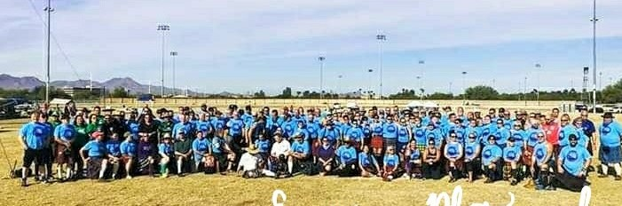

TCFA also, hosted a meet and greet for the athletes, with the trading of the American flag for the Irish flag to host the games in Ireland in 2020. (subject to change)
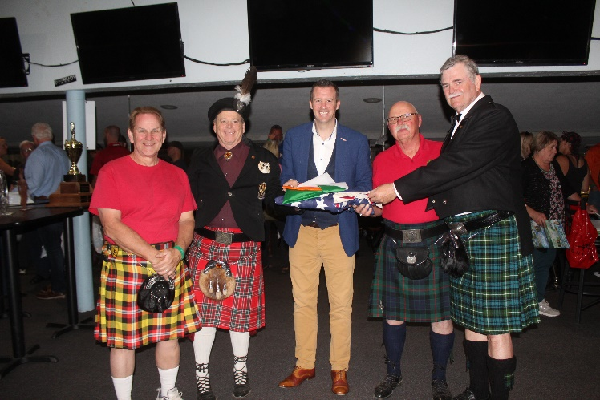

Photos from our 33rd Festival and Games 2019:

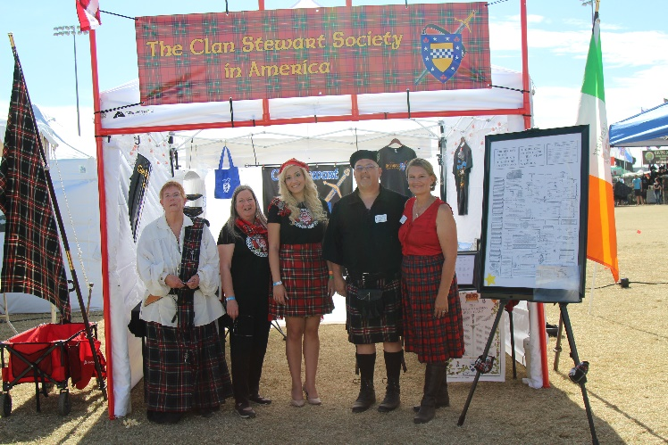
Clan Stewart

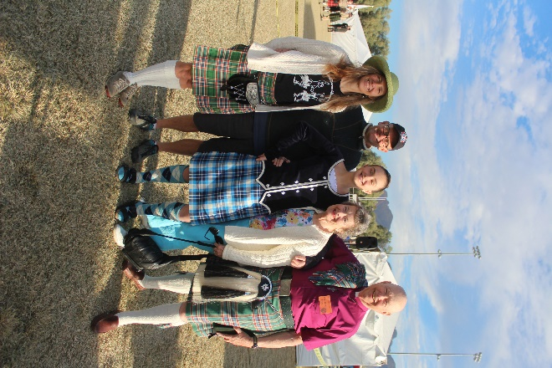
Rev. Knox and his family

Clan MacPherson
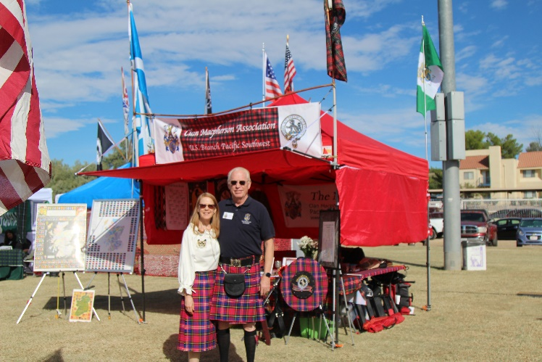

Clan Gunn
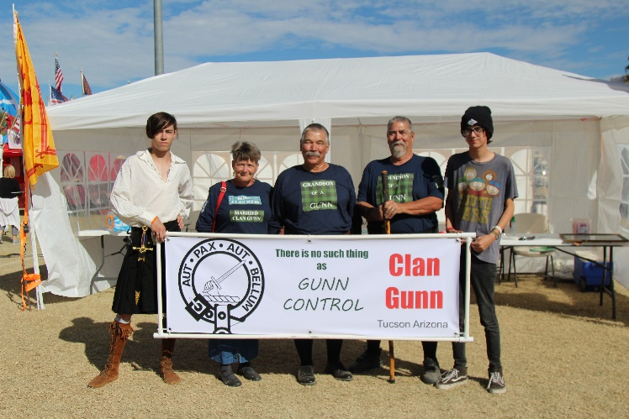

Tucson Scottish Highland Bagpipe Band
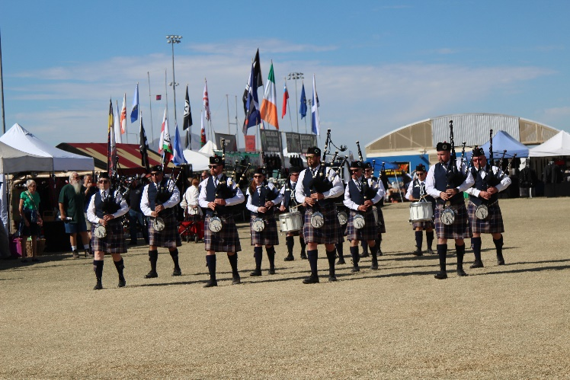

Funnel Cakes-Outstanding
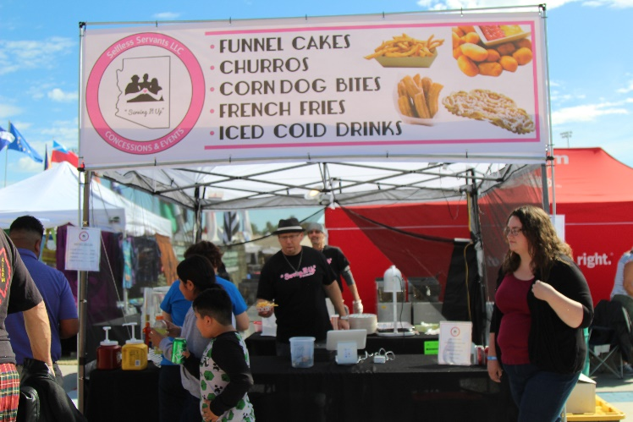

Female Athletes
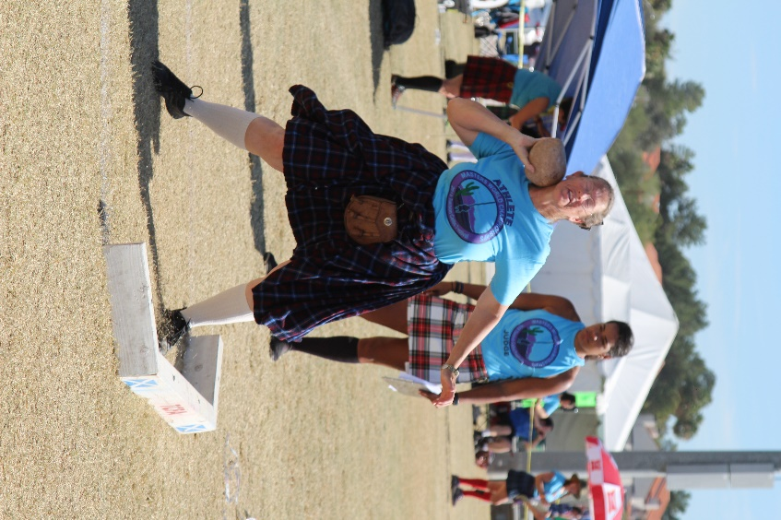

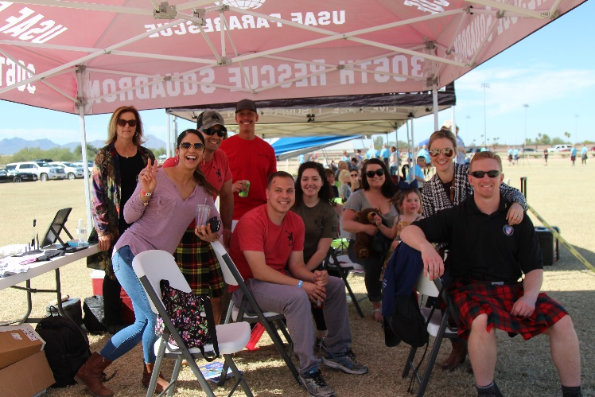
Families of the Athlete’s

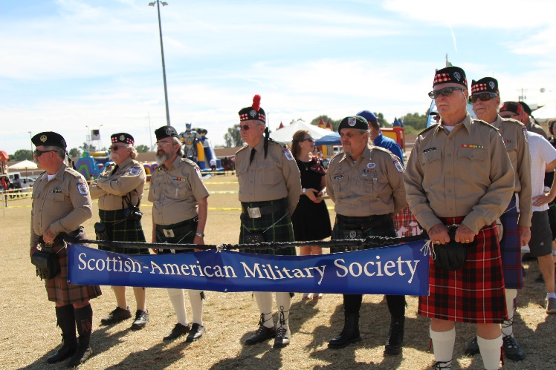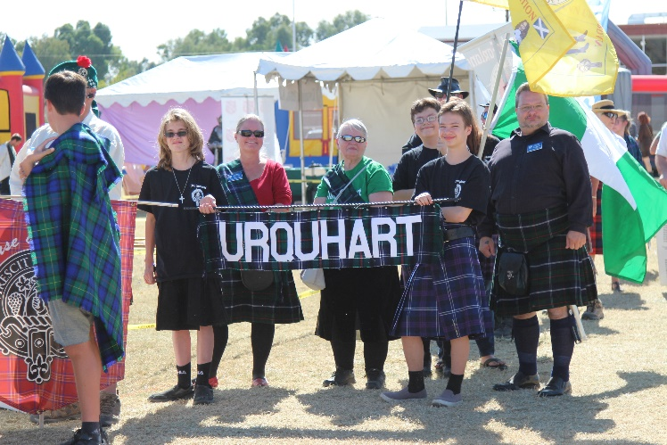

POEM

An Old Irish Blessing

May love and laughter light your days and warm your heart and home.
May good and faithful friends be yours, wherever you may roam.
May peace and plenty bless your world with joy that long endures
May all life’s passing seasons bring the best to you and yours!

EDITOR: ALEXENDRA MACPHERSON-MUNRO

Some of you know me, but for those of you who are new to TCFA, I would like to introduce myself, and give you a bit of background. I am Lady Alexandra MacPherson-Munro (my official title), and I am the new editor of the TCFA newsletter. I have been with TCFA for approximately 8 years. I have and associate’s degree in business with my major in paralegal studies. My background on writing is that I have written for Celtic Family Magazine, Royal Central online, Daughter of Scotia-Spirit of Alba Lodge #264 newsletter (2 years). I have also supplied photos to the St. Patrick’s Day parade for their program, as well as Desert Shamrock magazine. I have been the official photographer for TCFA for the past three years and loving every minute of it. I am the Past Chief Daughter of Spirit of Alba Lodge #264. As for my clans they are MacPherson and Munro. I continue to learn every day about my Scottish heritage, and I hope you all will get involved by submitting stories of your clans, or athletes, or whatever will be coming up. I welcome all information as well as input. Just remember this is not my newsletter; it is OUR NEWSLETTER.
I have included a section for Scottish or Celtic recipes along with the drink that will compliment that recipe.
I will do my utmost best to provide a well-informed newsletter. I look forward to sharing information in this newsletter to all members and I hope you will enjoy it.
Respectfully,
Lady Alexandra MacPherson-Munro
Editor

RECIPES
Some people don’t know this, but a breed of black hornless steers called Aberdeen Angus or Black Angus, originally bred in the counties of Aberdeen and Angus in Scotland, was brought to the United States and in a short time replaced the longhorn as the preferred beef steer. There was a Scot, George Grant, introduced “the freaks because of their lack of horns and jet black colour” at the Kansas City Livestock Show in 1873. The massive, meaty Black Angus provided the loading source for what is called Scotch beef.
Aberdeen Angus Whisky Steaks
1/2 cup (1/2 stick) unsalted butter
1 large yellow onion, cut crosswise and thinly sliced
4 center-cut filet steaks
1/2 cup beef broth
1/2 tsp. freshly ground black pepper
1/4 cup Scotch whisky

In a large skillet, melt butter over medium heat. Add onions slices; sauté’ until tender, 4 minutes. Remove to a plate and keep warm. Add steaks to drippings and sear over high heat for 1 minute on each side. Reduce heat to medium low and cook steaks for about 4 minutes on each side for medium rare. Remove to warm plates.

Increase the heat to medium high. Add broth, stirring and scraping up all the browned bits on the bottom. Cook for 2 to 3 minutes, until the liquid is reduced by half. Season with pepper. Add whisky. Heat for 1 minute. Pour over steaks. Garnish with onions. Serve with a pat of butter on top of each, if desired. Serves 4.

Rob Roy Drink

This Scottish drink takes its name from the famous Highland outlaw, Rob Roy. It has been a popular drink in American for devotees of Scotch whisky.

2 ½ oz. Scotch whisky
½ oz. dry vermouth
1 lemon peel

Pour whisky and vermouth into mixing glass filled with ice. Strain into a chilled cocktail glass. Twist lemon peel over the drink. Drop peel into the glass. Serves 1.
Featured Clan
Coming Soon

Featured Athlete
Coming Soon

Upcoming Birthdays, Births, Weddings, Anniversaries

June 16 – Alexandra Munro

